ASSIGNMENT 1
1. Create 'spj' database'. (Database for suppliers, parts and
jobs)
2. use spj database;
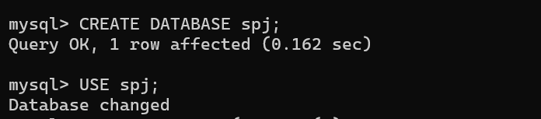
3. Create following tables in spj database.
S table :
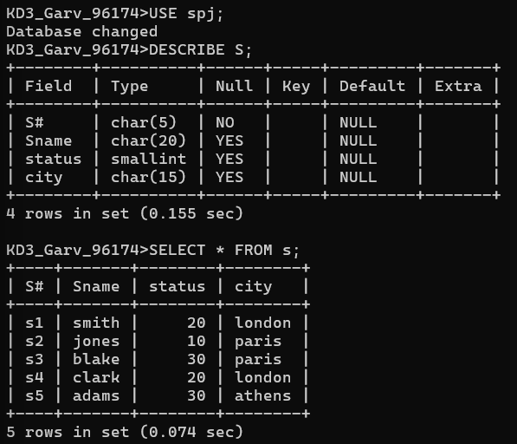

P table :
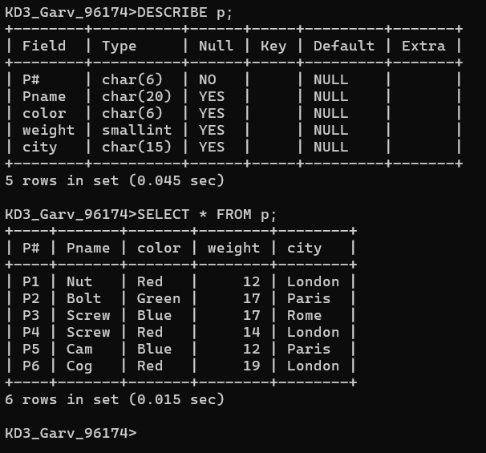

J table :
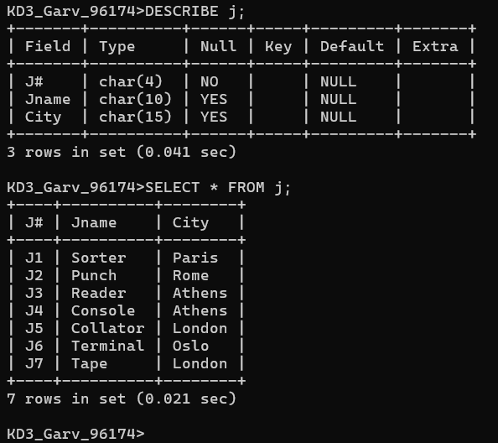

SP table :
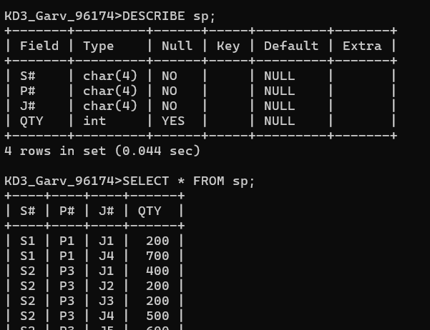

1. Create 'hr' database. Import hr-db.sql.
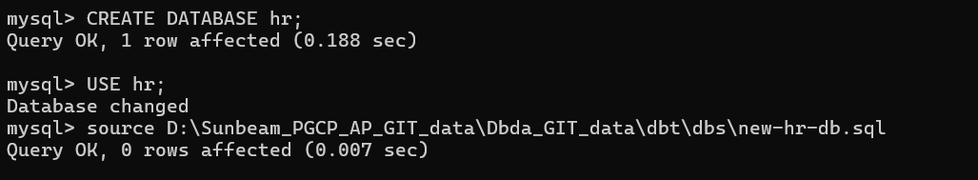
2. Create 'sales' database. Import sales-db.sql.
3. List all tables in hr database. Display contents of all tables
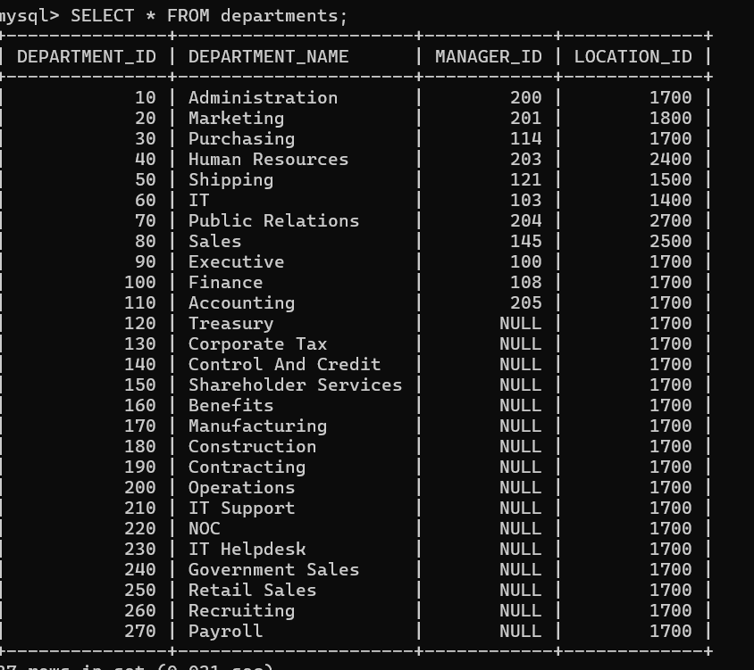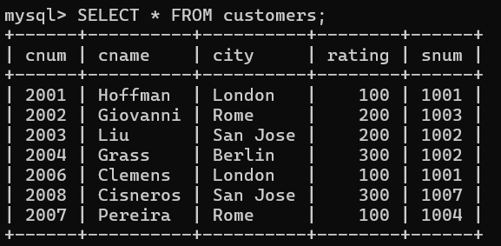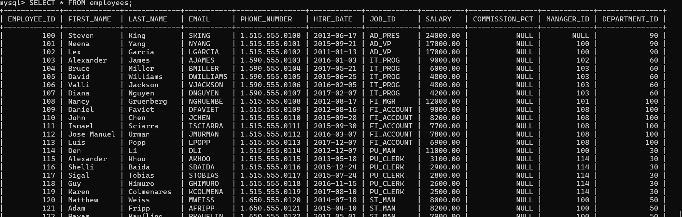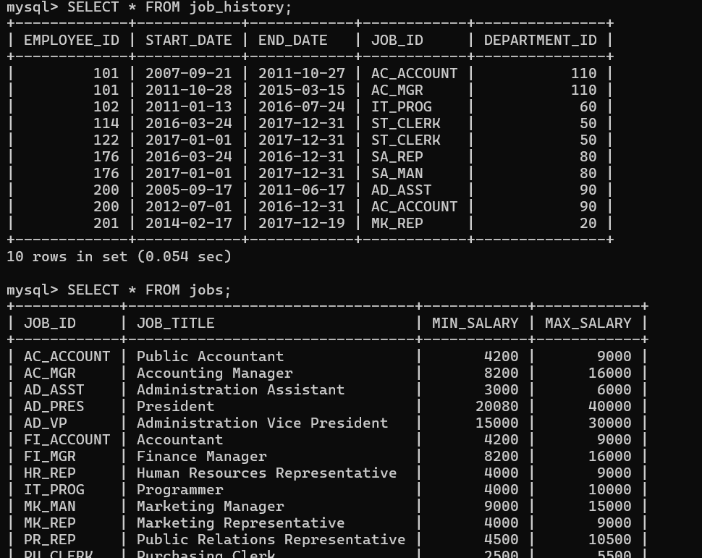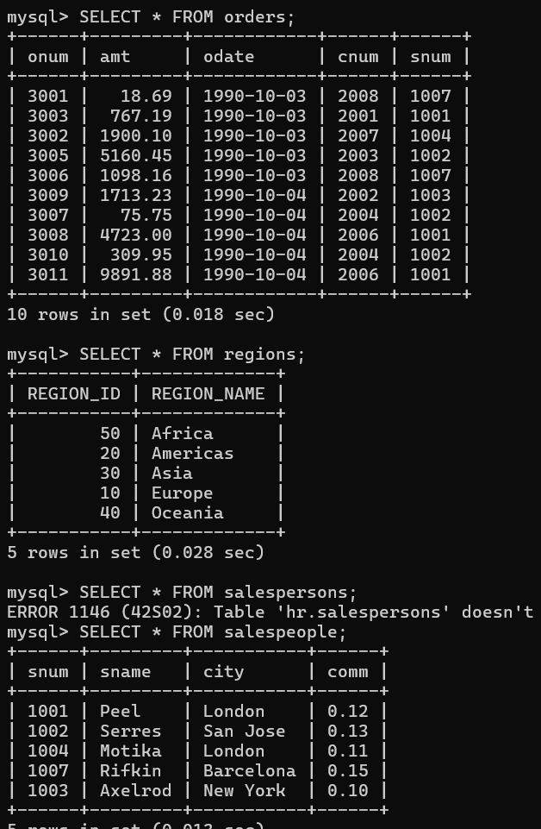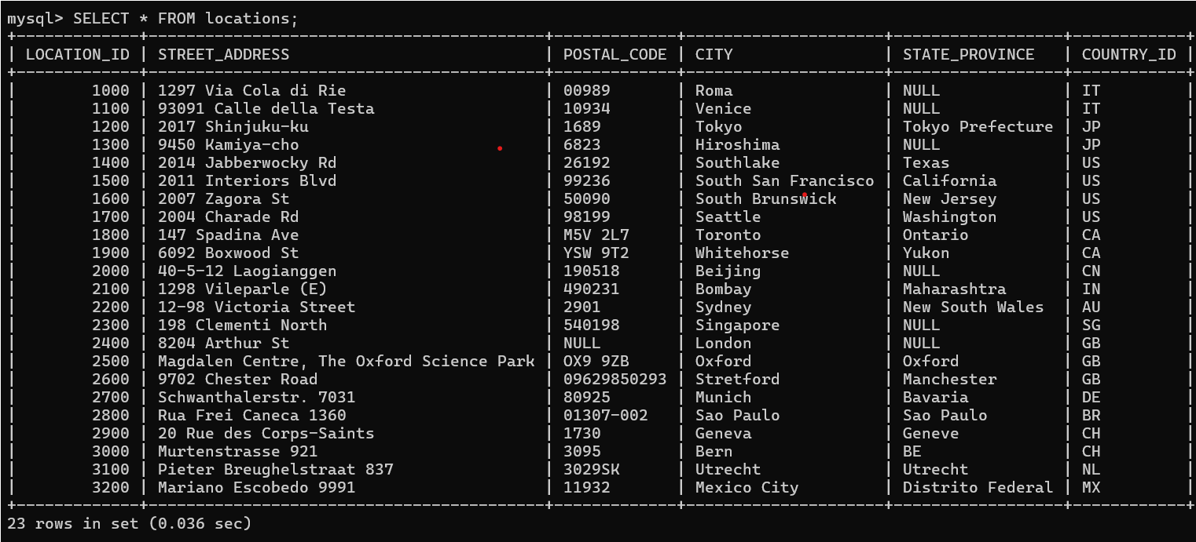
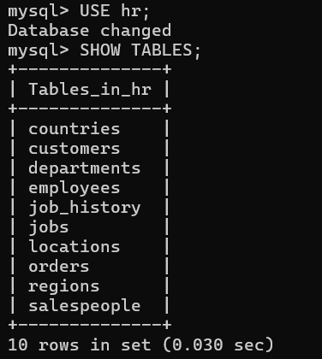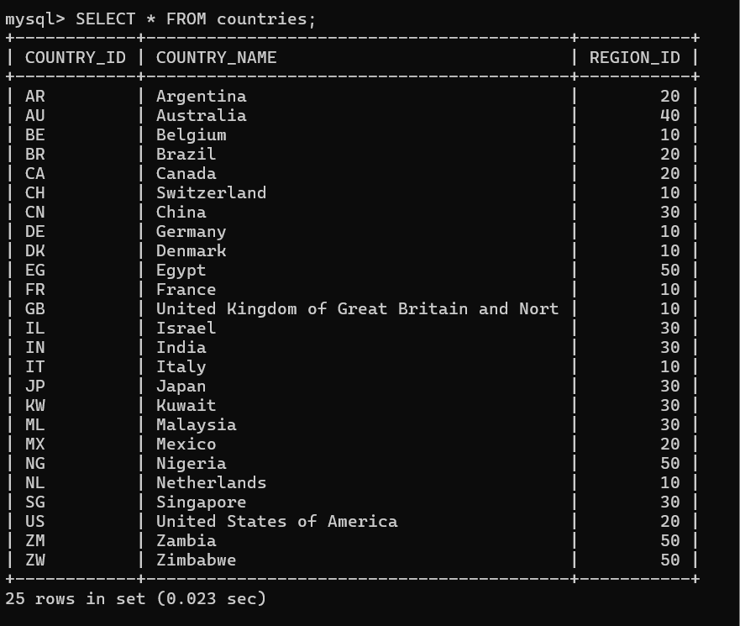

4. List all tables in sales database. Display contents of all tables (one by one).
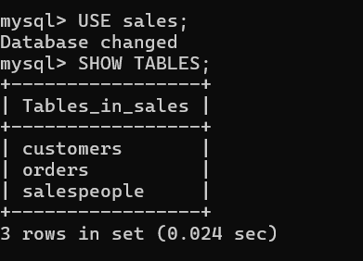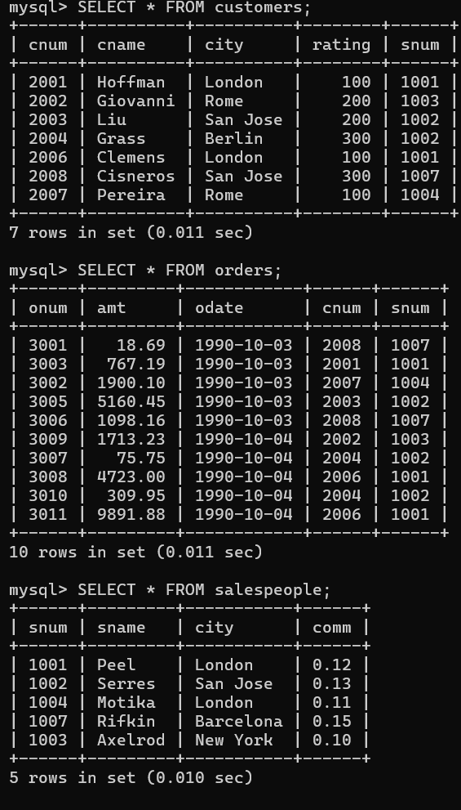

Answer the following questions (by observations only – not queries).
- How many orders data is present in the database?
Ans. 10
- How many customers are present in the database?
Ans. 7
- How many salespeople are present in the database?
Ans. 5
- On which date order with highest amount is placed?
Ans. 1990-10-04
5. For which order salesman got maximum commission? Hint: you need to
refer data of two tables.
Ans. 3011
6. Which salesmen are handling more than two customers? Hint: you need to
refer data of two tables.
Ans. Peel
7. Which city have single customer?
Ans. Berline
8. Which city has multiple salespeople?
Ans. London
9. What is name of customer and salesman of the maximum amount order?
Ans. Customer : Clemens , Salesman : Peel
10. Study relationship between the tables in sales database.
Ans. A salesperson manages many customers.
A customer places many orders.
Each order belongs to one customer and one salesperson.

